**Project 5 - Shader**

Screenshot:

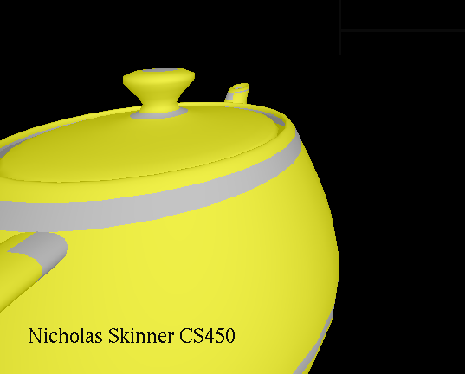

Video Link: <https://media.oregonstate.edu/media/t/0_vfw9xrrh>

Thanks, and have a great day!